# HBase – Exercise 1

## Screenshot of scan 'practice:students' output from HBase Shell

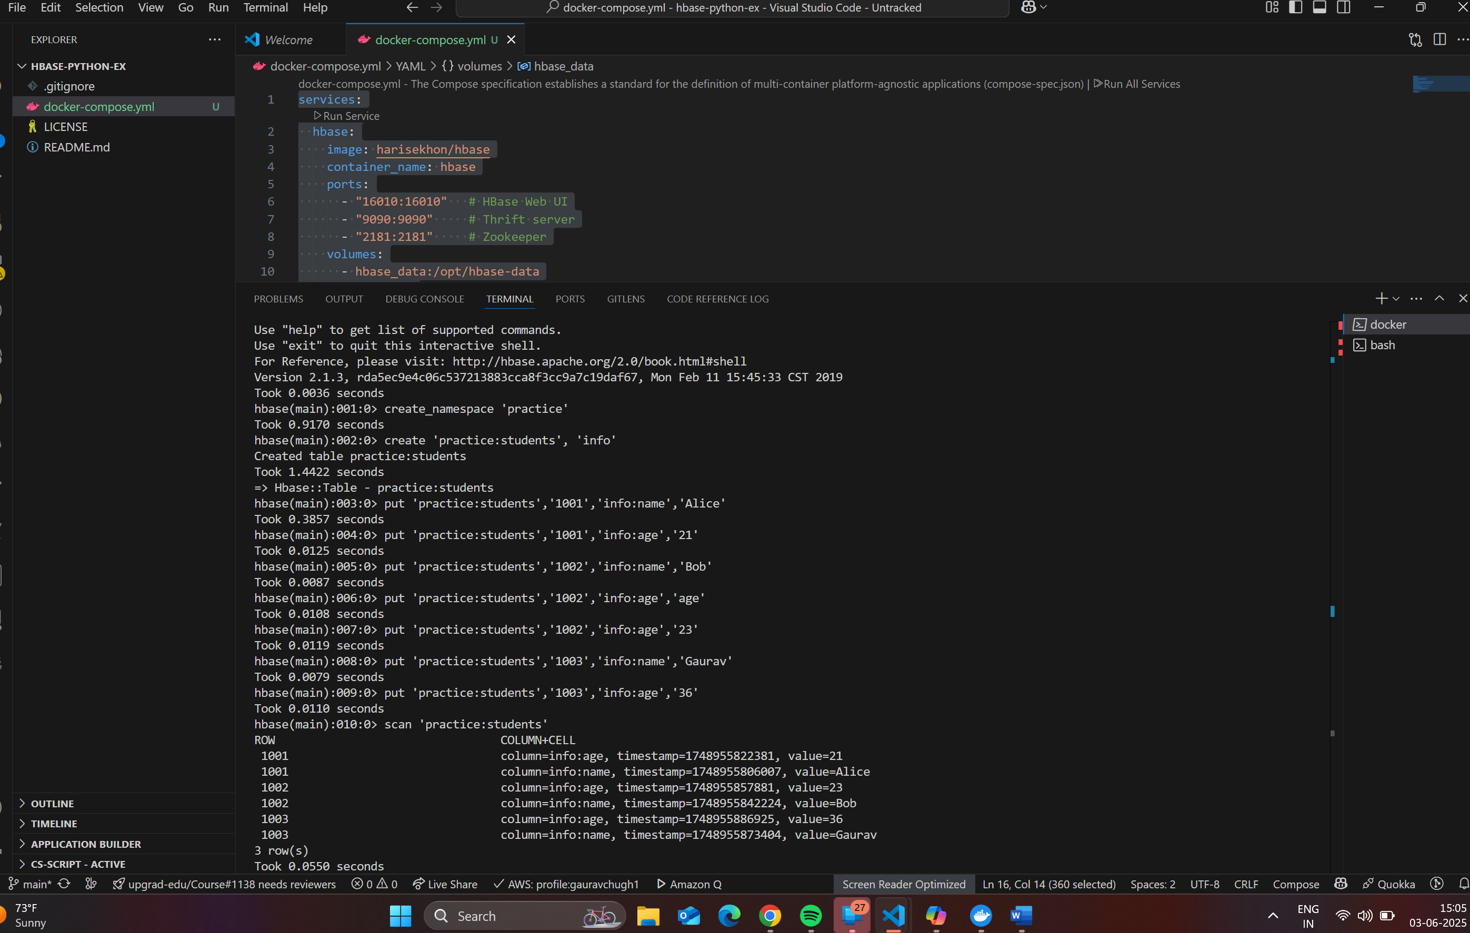

wget -c <https://data.lacity.org/api/views/2nrs-mtv8/rows.csv>

curl -O -C <https://data.lacity.org/api/views/2nrs-mtv8/rows.csv>

curl -O -C - --insecure "https://data.lacity.org/api/views/2nrs-mtv8/rows.csv" worked

certutil -generateSSTFromWU rootca.sst

wget -c "https://data.lacity.org/api/views/2nrs-mtv8/rows.csv"

# HBase - Exercise 2

## All crimes in Hollywood in 2020

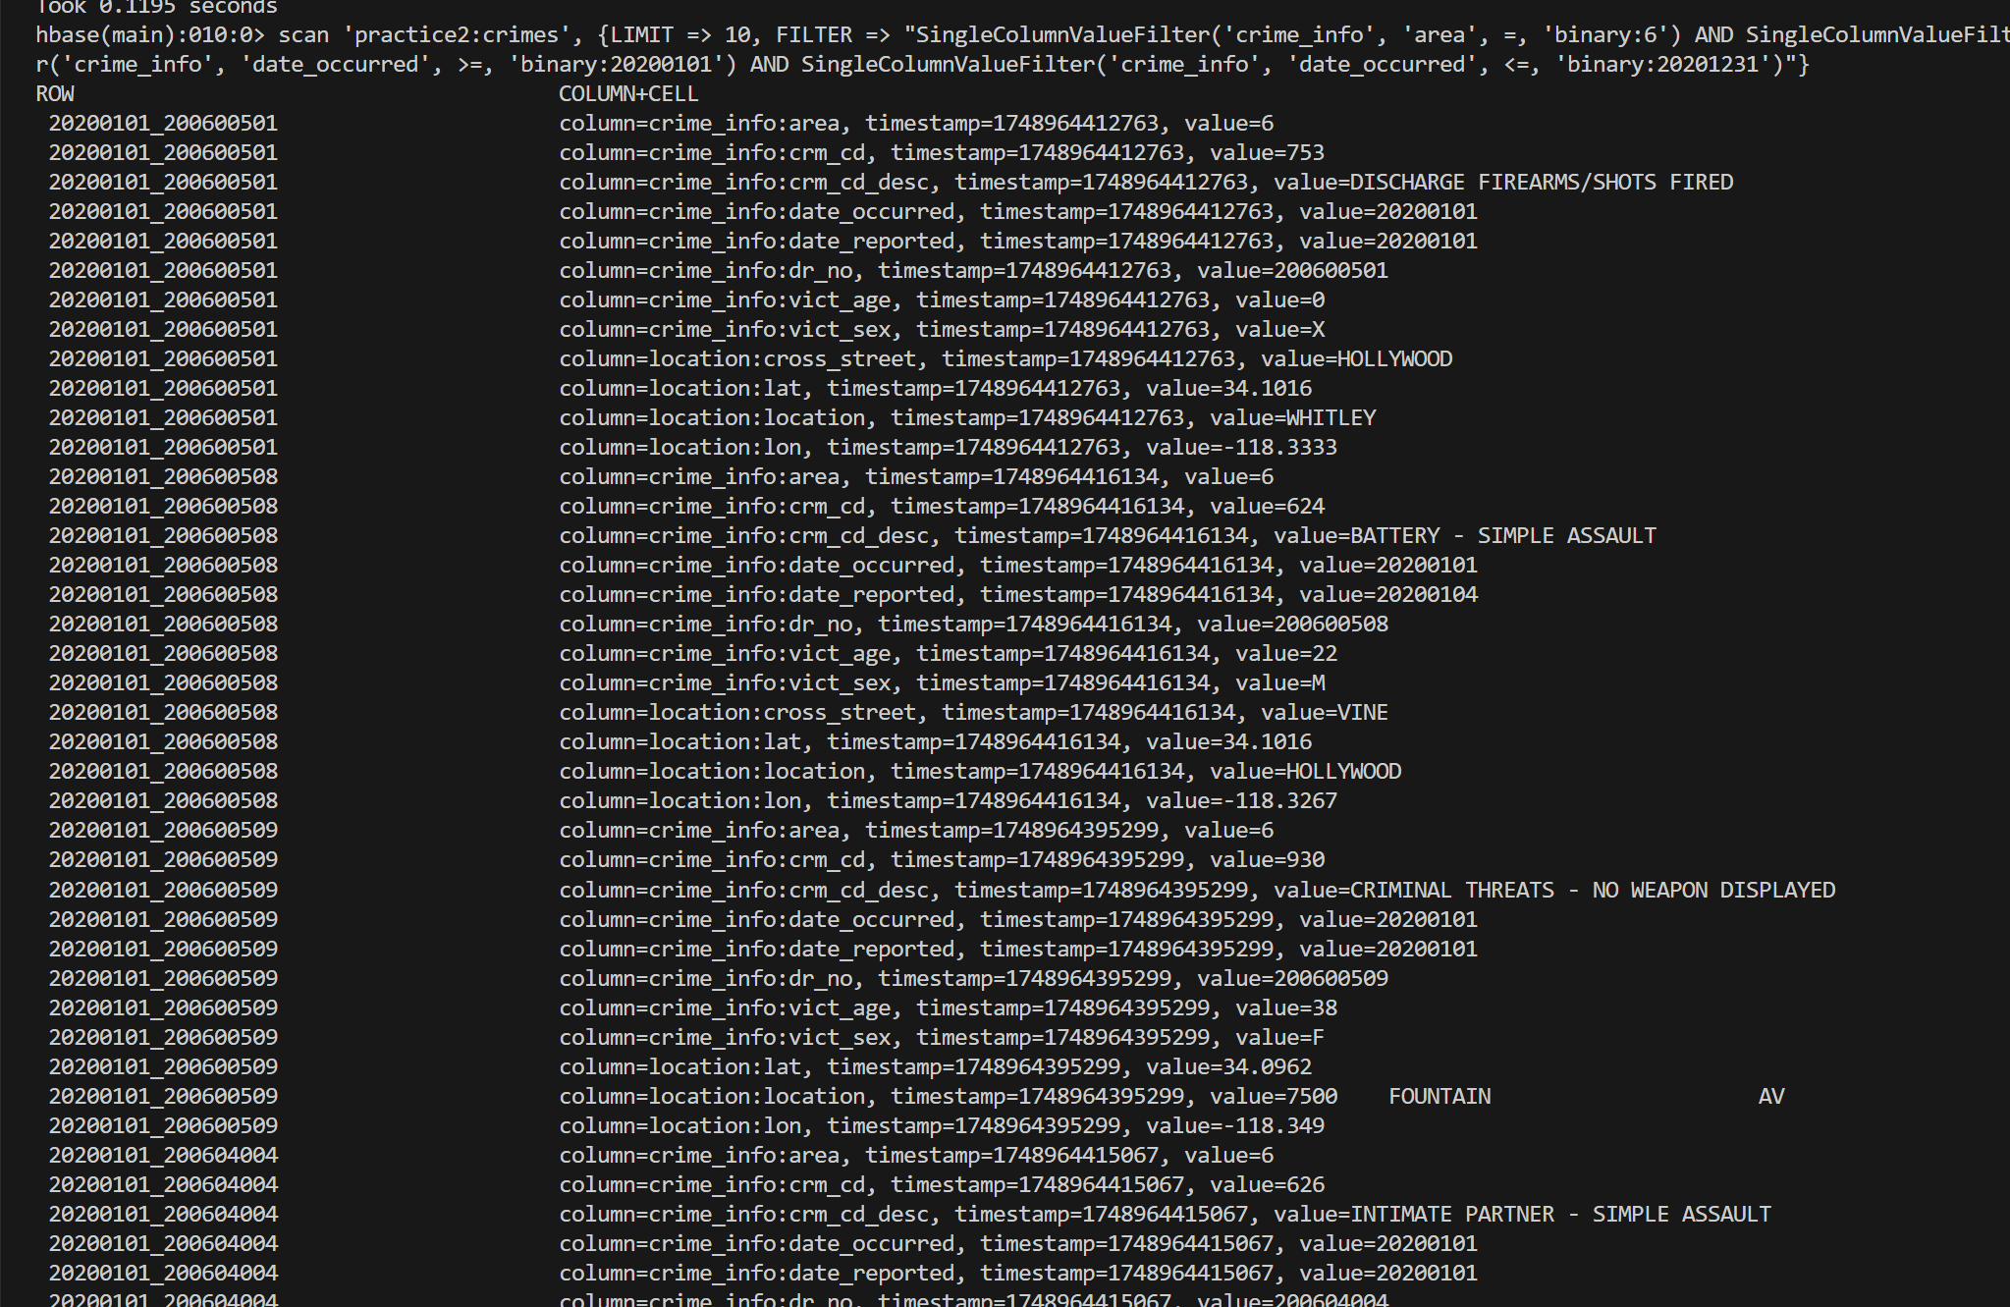

## Count the number of rows of our crimes table

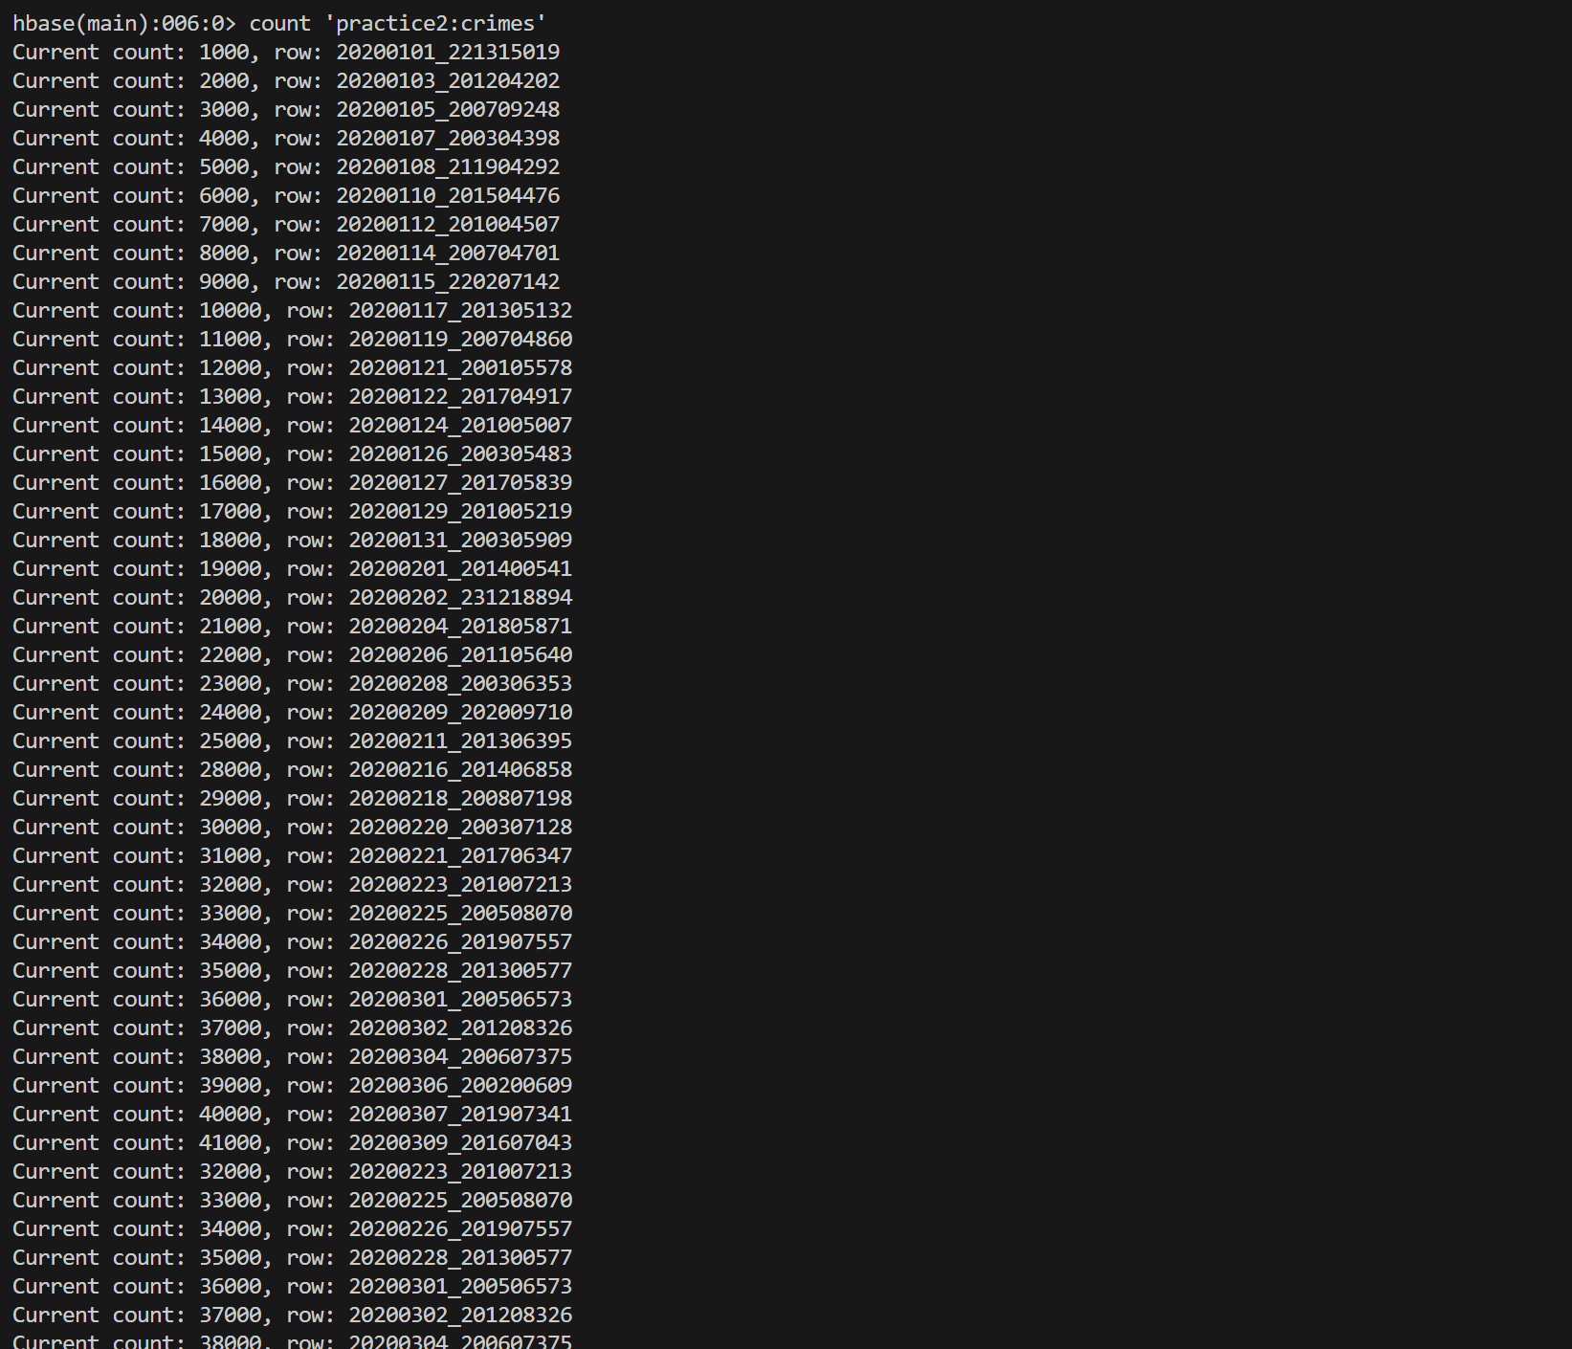

Limit 10

scan 'practice2:crimes', {LIMIT=> 10, FILTER => "SingleColumnValueFilter('crime_info', 'crm_cd_desc', =, 'regexstring:SHOPLIFTING')"}

## First 10 SHOPLIFTING & VANDALISM Crimes in February 2020

scan 'practice2:crimes', {LIMIT => 10, FILTER => "(SingleColumnValueFilter('crime_info', 'crm_cd_desc', =, 'regexstring:SHOPLIFTING') OR SingleColumnValueFilter('crime_info', 'crm_cd_desc', =, 'regexstring:VANDALISM')) AND SingleColumnValueFilter('crime_info', 'date_occurred', >=, 'binary:20200201') AND SingleColumnValueFilter('crime_info', 'date_occurred', <=, 'binary:20200229')"}

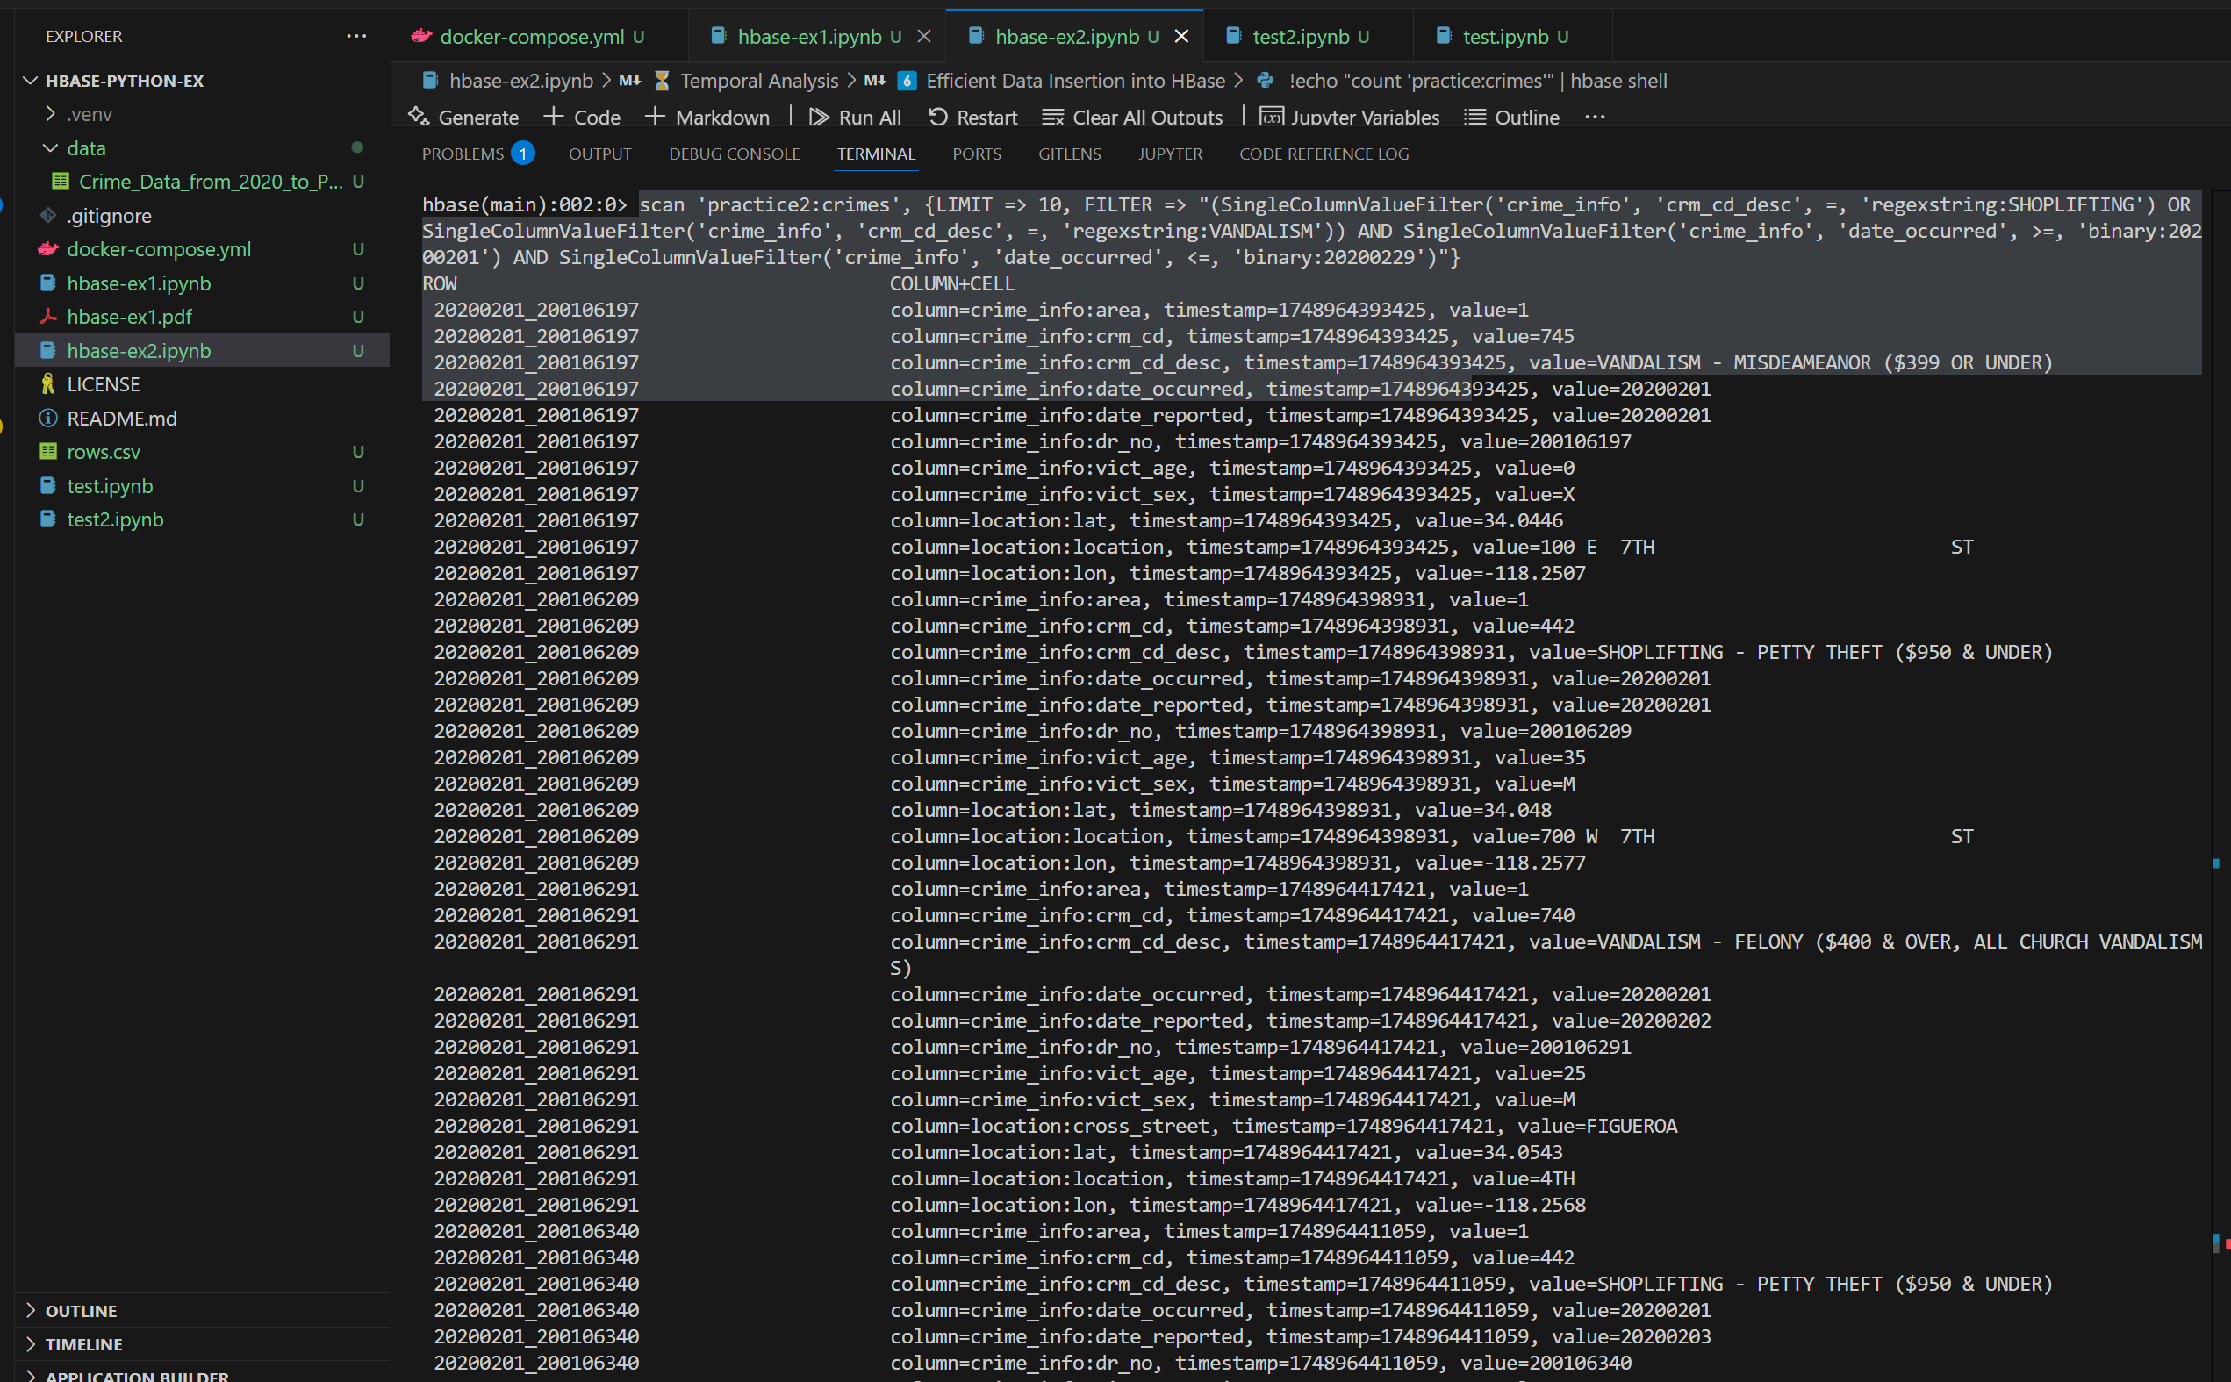

## Victim Age & Sex for INTIMATE PARTNER - SIMPLE ASSAULT (April 2020)

scan 'practice2:crimes', {LIMIT => 10, FILTER => "SingleColumnValueFilter('crime_info', 'crm_cd_desc', =, 'binary:INTIMATE PARTNER - SIMPLE ASSAULT') AND SingleColumnValueFilter('crime_info', 'date_occurred', >=, 'binary:20200401') AND SingleColumnValueFilter('crime_info', 'date_occurred', <=, 'binary:20200430')", COLUMNS => ['crime_info:vict_age', 'crime_info:vict_sex']}

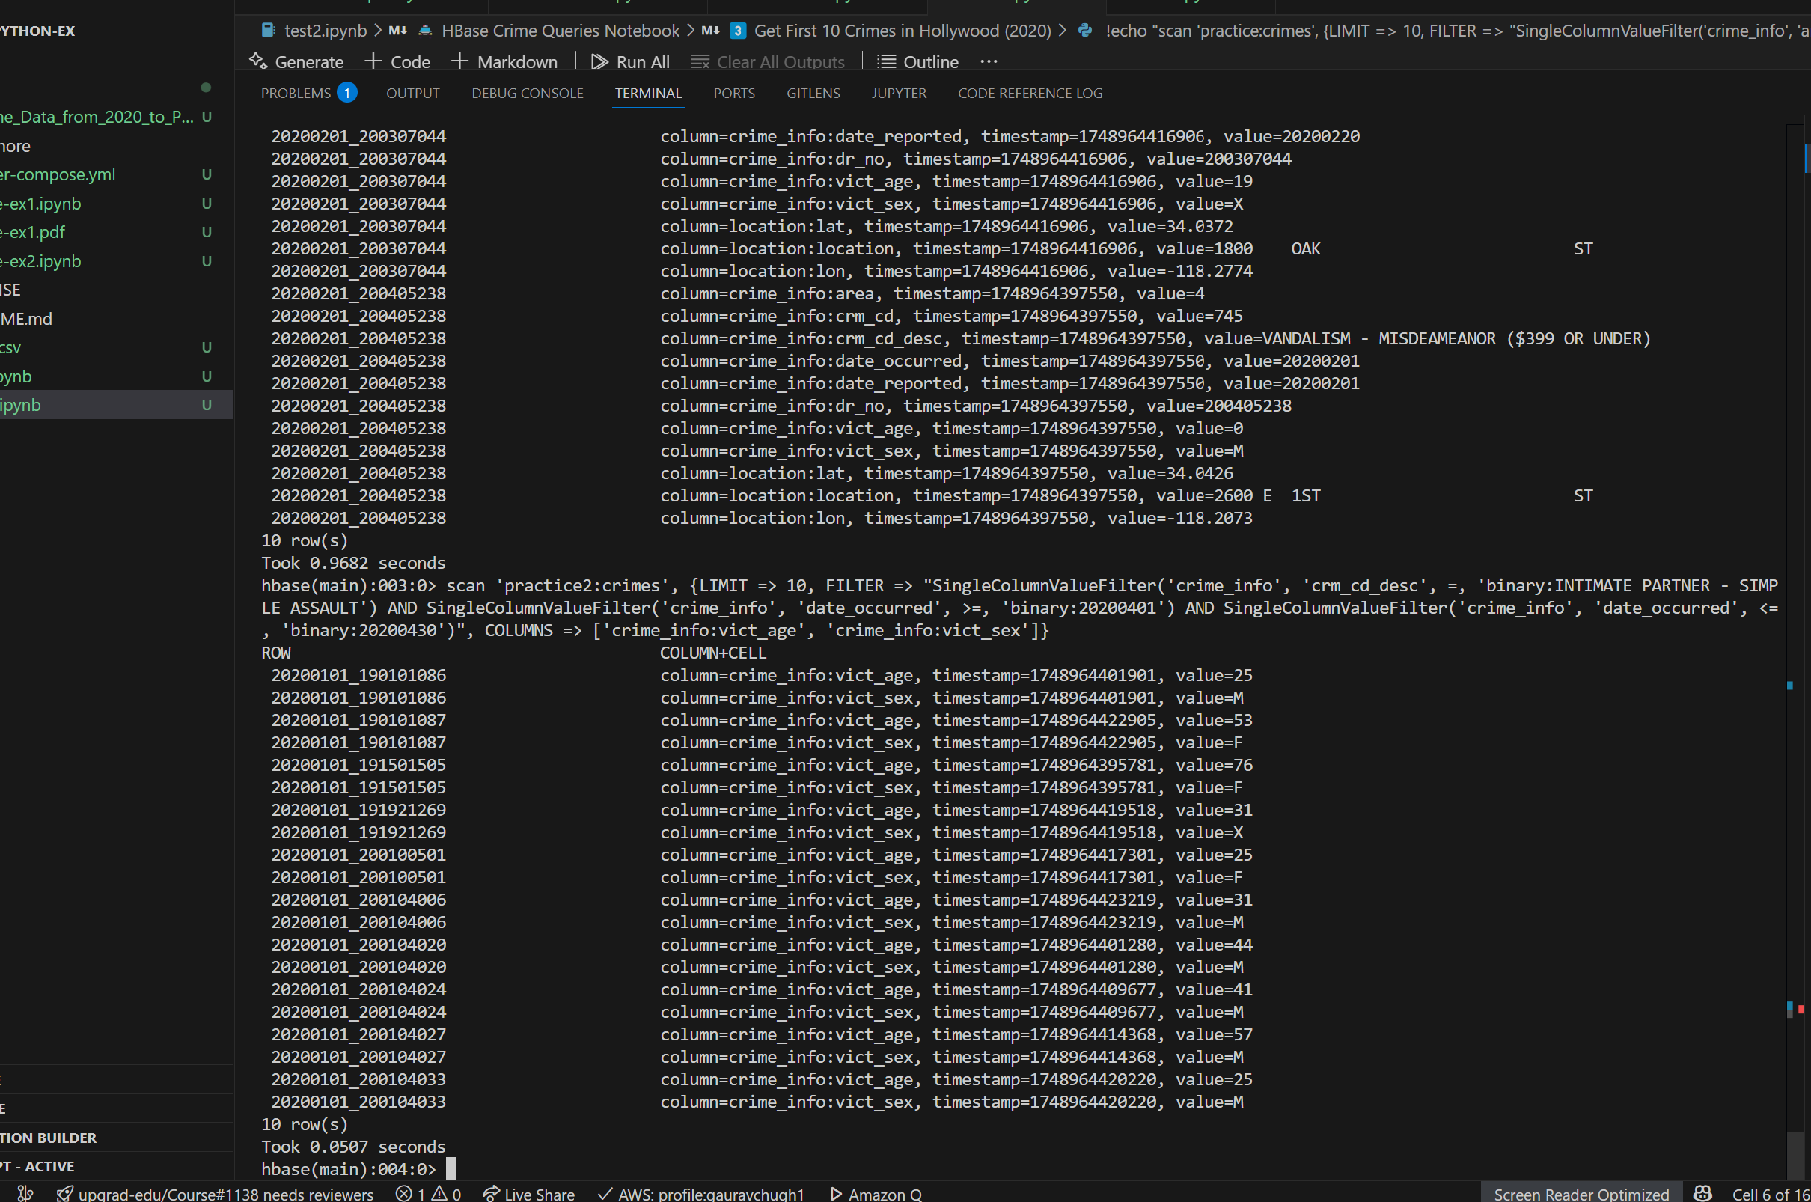

## Crimes reported on 03/12/2020

scan 'practice2:crimes', {LIMIT => 10, FILTER => "SingleColumnValueFilter('crime_info', 'date_reported', =, 'binary:20200312')"}

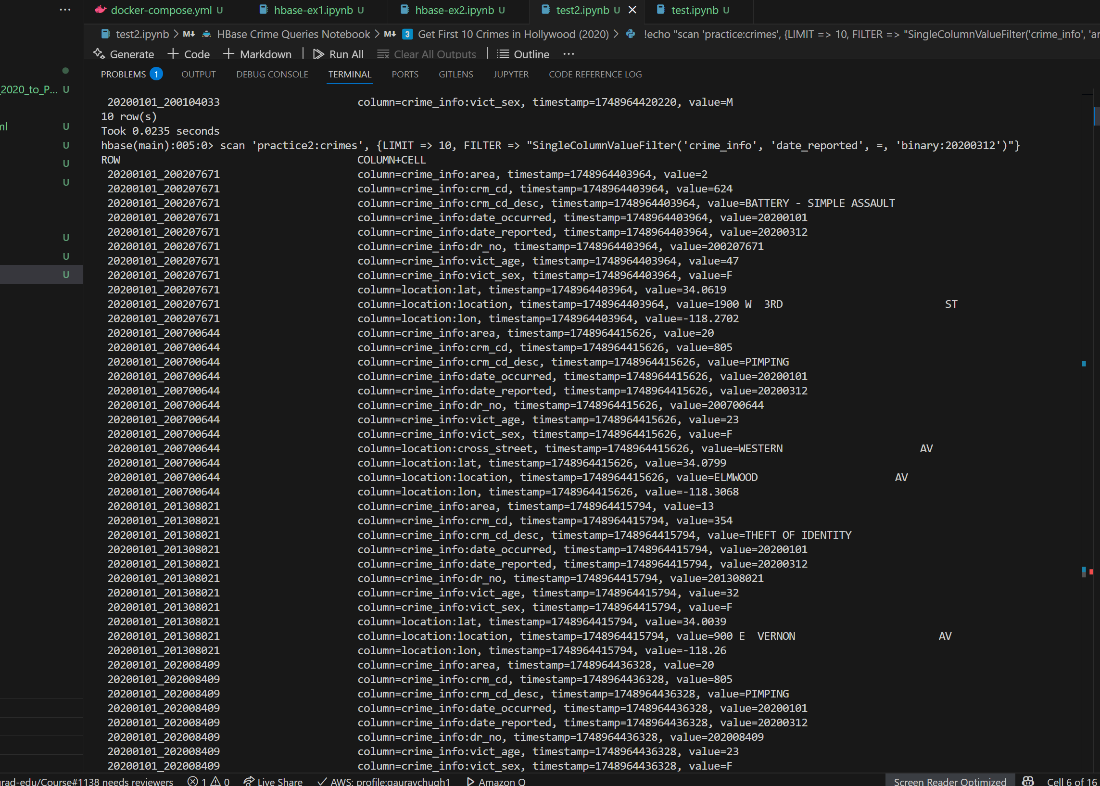

## Crimes Between 02/01/2020 and 02/02/2020 in Wilshire on Female Victims

scan 'practice2:crimes', {LIMIT => 10, FILTER => "SingleColumnValueFilter('crime_info', 'date_occurred', >=, 'binary:20200201') AND SingleColumnValueFilter('crime_info', 'date_occurred', <=, 'binary:20200202') AND SingleColumnValueFilter('crime_info', 'area', =, 'binary:7') AND SingleColumnValueFilter('crime_info', 'vict_sex', =, 'binary:F')"}

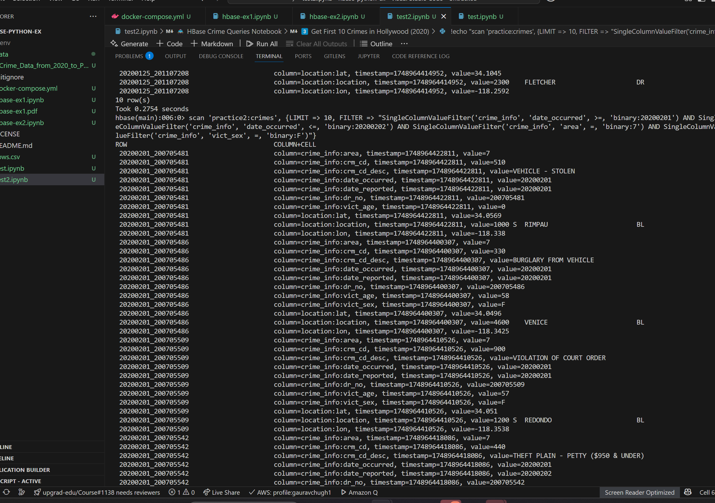

## No of Regions and Region Servers

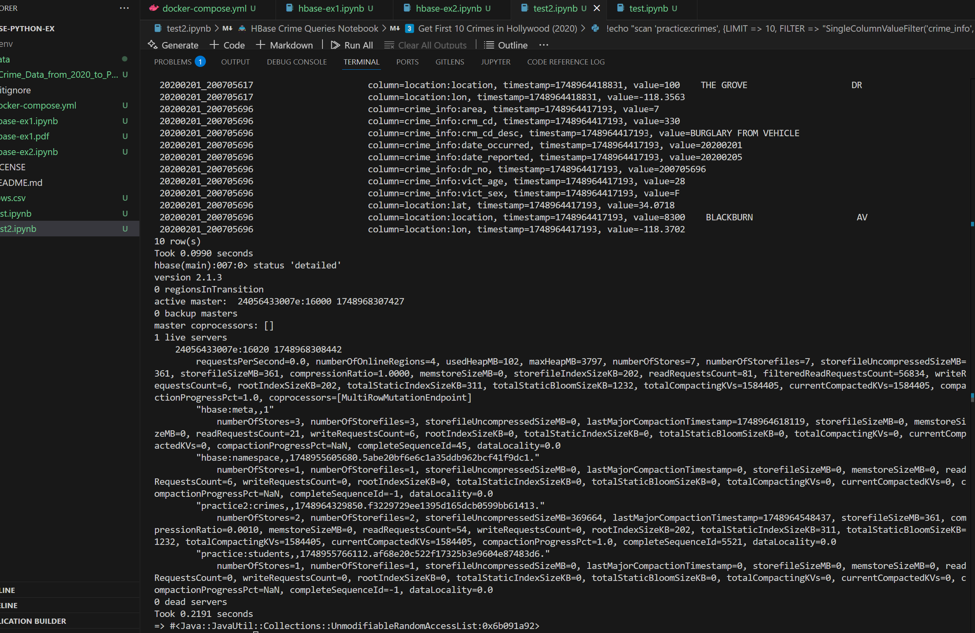

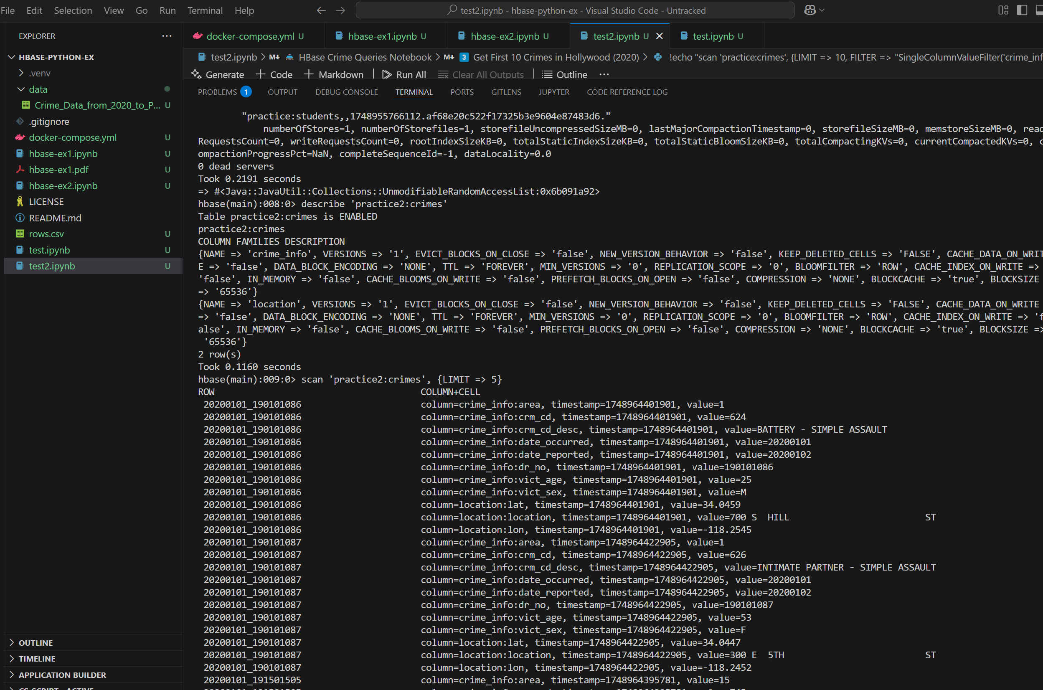

jupyter nbconvert --to pdf your_notebook.ipynb